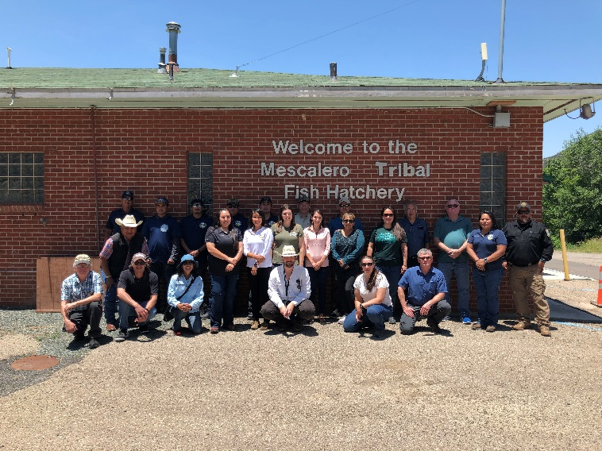
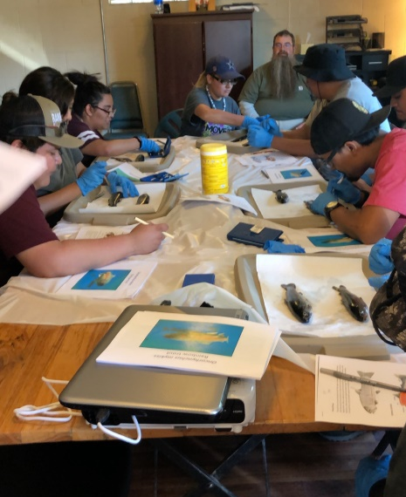
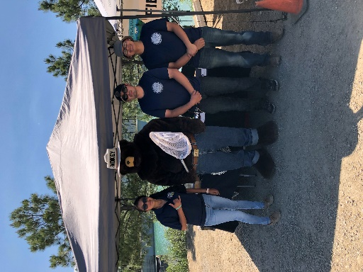
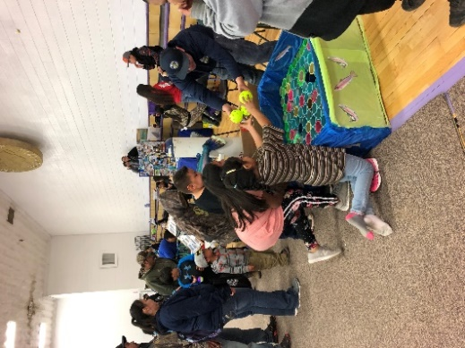
Hello Everyone! From the Fish Hatchery. Summer 2019 has been a very busy yet successful summer to start with. In the beginning of the year we have had many tours from several schools, summer programs and just curious locals from all over New Mexico. It is our pleasure to spread awareness of the Hatchery as we love our jobs and the duty’s that come along with working at the Hatchery. We have participated in several events that took place within the Reservation and Lincoln County. Just to name a few, the Community Fun Day in Mescalero, the 75th Annual Smokey Bear Day in Capitan, the 25th Annual Fishing Day at Grindstone and more to come. Every year we hire Summer Youth and WIOA workers that engage in helping rearing of fish and other projects thought-out the hatchery grounds. This year we are happy to announce our new summer youth workers; Mihlene Hosetosavit, Gabriel Marrujo, Randy Taazah and Jeremiah Bigmouth. We are pleased to share that the South West Tribal Fisheries Commission will be funding a Summer Youth in Fisheries, Natural Recourses and Forests Project in collaboration of the US-Forrest Service located in Ruidoso, NM. The month of June played a big role of scheduled events, the Fish Hatchery took part in the Discovery Camp. That day several students from SIPI of Albuquerque and students of Mescalero took part in Necropsy of Trout, that involves dissecting and looking at the overall health of your fish. Several students also took part in retrieving in sample lengths, that involves getting into the water and monitoring the growth of our fish. Hands-on is a wonderful way to engage a learning experience. The Fish Hatchery has been planning for a site visit from Mr. David Wooten, Chief of Fish, Wildlife and Recreation of BIA with many regional personnel from all over the United States. The tour was a great success, they saw the many improvements we as a hatchery had achieved through the years. We are very proud from where we came from to where we are at now! We have accomplished so much with what little we had. With their help we hope to fulfill, and exceed the boundaries of what the hatchery is capable of. The possibilities are endless. We would like to encourage our community as well as surrounding communities to come see the improvements we have over the years. Tours are more than welcome, please call in advance for large group tours. See you then… Thank You, Fish Hatchery Staff!

