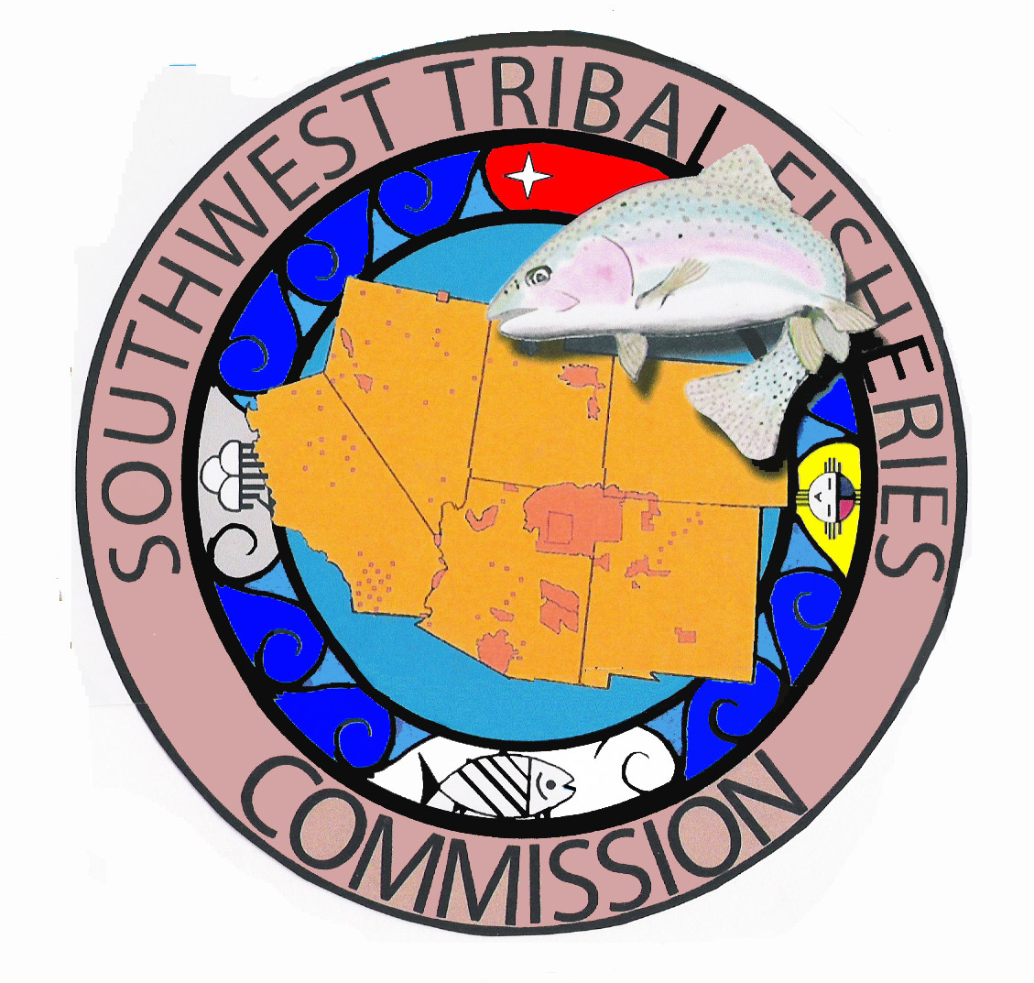
SOUTHWEST TRIBAL FISHERIES COMMISSION

ANNUAL MEETING – November 14, 2019 9:00 AM

BIA Training Building, Room #271, 1011 Indian School Road NW,
Albuquerque, NM, 87104

CALL IN INFORMATION: 1-866-914-7568. Pass code: 64418784.

AGENDA

9:00 – 9:15 Call to Order (Adam Ringia)
- Invocation
- Introductions
- Overview

9:15 – 9:30 Secretary-Treasurer Report (Steve Whiteman)
- Approval of Past Minutes
- Financial Report

9:30 – 9:45 Chairman Report (Jacob Mazzone)
- Congressional responses
- Updates – Colorado River Basin/3 Species meeting

9:45-9:55 Vice Chairman Report (Glenn Selby)

9:50 – 10:15 Mescalero Tribal Fish Hatchery Report
- BIA funding updates; budgets and projections; truck update; canopy update; fish health; deliveries; youth updates; other news; issues and challenges

10:15-10:30 Break

10:30 – 11:15 Executive Director Report (Adam Ringia)
- 2020 Annual budget and resolution
- Upcoming workshops/trainings
- Meeting Reports – WGA conference
- Meetings with Member tribes
- Schedule Next Quarterly Meeting: January 2020
11:15 – 12:00 Partnership Updates
- U.S. Bureau of Indian Affairs
- U.S. Forest Service
- State?
- NAFWS/TU/BassNation
- Other Agencies and Partners

12:00 – 12:15pm Discussion
12:15 – 1:00 Lunch – Pizza – Provided by SWTFC

1:00 – 4:30 USFWS Annual Tribal Fisheries Meeting

