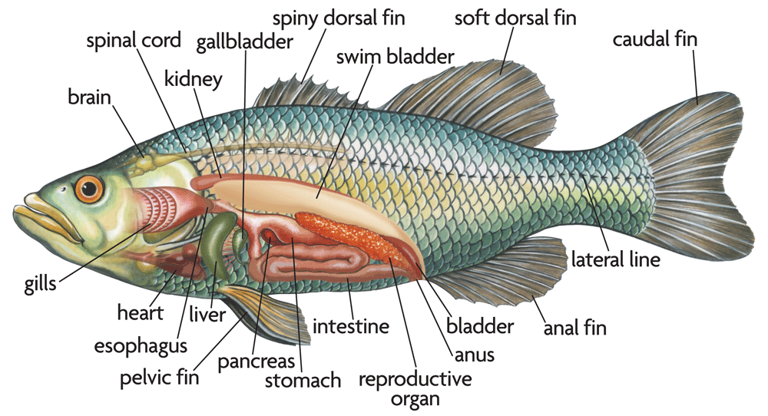fEBRUARY 25, 2020 10-2
Fish identifacation class REGISTRATION

Want to brush up on your fishy skills? Need to learn what kind of sharks you have in your water system? Or would like to just fine tune your fish identification.

This informational class will be hosted by the Pueblo of Sandia and presented by The United States Fish and Wildlife Service. Questions are welcome, pickled fish will be present for identification, and information of species in the different systems.

There is a limit to 20-25 (max), participants

Send your completed registration form to Timothy Smith at tsmith@sandiapueblo.nsn.us

NAME: ________________________________________________

TITLE: __________________________________________________

CONTACT: PHONE- _____________________________________

EMAIL- ______________________________________

TRIBAL AFFILIATION (WORK): _____________________________________________

